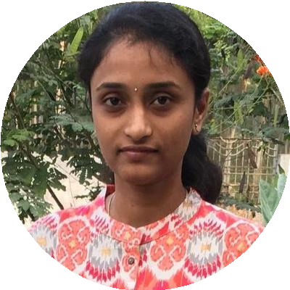



[achanta.venkatalakshmi@gmail.c om](mailto:achanta.venkatalakshmi@gmail.com)

Venkata Lakshmi Achanta

IT Analyst

Energetic and Passionate Professional.



8985993291

# WORK EXPERIENCE

## Tata Consultancy Services

### Synergy Park, Hyderabad

*07/2014 – Present Achievements/Tasks*

*Developer*

Hyderabad, India



[linkedin.com/in/venkata-lakshmi](https://www.linkedin.com/in/venkata-lakshmi)

# SKILLS

Java

Struts

##### Involved in all aspects of Software Development Life Cycle. Design, build, or maintain web sites

using authoring or scripting languages, content creation tools, management tools, and digital media.

Perform or direct revision, repair, or expansion of existing programs to increase operating efficiency or adapt to new requirements.

Document test plans, testing procedures, or test results. Train subordinates in programming and program coding.

**PROJECTS**

Spring

Java Script

Fiat Chrysler Automobiles (10/2014 – Present)

JSP

JQuery

DB2

About Client : Fiat Chrysler Automobiles, also known as FCA, is an Italian-American multinational automobile manufacturer. Mopar (Motor and Parts) is the Parts, Service and Customer Care organization within Chrysler Group. MOPAR handles the sourcing and distribution of service parts across the geographies for Fiat- Chrysler.

HTML

JUNIT

Mopar Supplier Charge-back Application (04/2019 – Present)

Jenkins

Technology : Spring, Web Application Development, Spring Batch, Git Hub

**Azure** **Portal** : Web Jobs, Cloud Database, Send Grid, Cloud Storage.

Developing Business Requirement.

#### XDB Mopar Accessory Engineering Database (11/2017 – 03/2019)

App Scan Security

Technology : Spring,Spring Batch.

Developing and Enhancing Business Requirement.

DB Visualizer

Implemented Spring Batch Programs to pull data from Database and placed in Server location using FTP and sends an email using SMTP .(Spring Batch : 06/2018-07/2018).

Serena Dimensions

#### Service Bill of Material & PTDP Parts Technical Development Portal (10/2014 – 03/2019)

Technology : Java,Struts & Mainframes Developing and Enhancing Business Requirement.

File Zilla

COBOL

#### 

CICS

JCL

Hadoop

**LANGUAGES**

##### English

*Full Professional Proﬁciency*

##### Telugu

*Native or Bilingual Proﬁciency*

##### Hindi

*Professional Working Proﬁciency*

# INTERESTS

**EDUCATION**

## Bachelor of Technology

### Godavari Institute of Engineering and Technology, Rajahmundry.

*08/2010 – 05/2014*

*Courses*

##### Electronics and Communication Engineering

**Intermediate**

Aditya Junior College,Kakinada.

*06/2008 – 05/2010*

*Courses*

##### MPC

*79%*

*96.2%*

# ACHIEVEMENTS

Surﬁng Internet

#### Rookie of the Month (07/2015 – 07/2015) Star of the Month (02/2017 – 02/2017)